275 W Frameless BLDC Motor
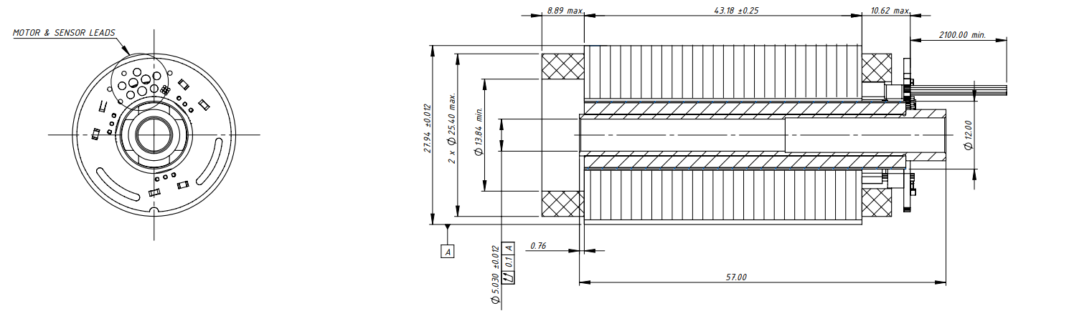
Basic Motor Parameters
Rated Power | W | 275
Rated Speed | rpm | 25000
Rated Torque | Nm | 0.105
Rated Current | A | 4
Rated Voltage | V | 120
No-Load Speed | rpm | 30000
Max. Efficiency | % | 85
Electrical Parameters
Number of Phases |  | 3
Number of Poles |  | 4
Torque Constant (KT) | Nm/A | 0.0423
Back EMF Constant (KE) | Vs/rad | 0.0417
Terminal Resistance Phase to Phase (±%10) | mΩ | 1100
Terminal Inductance Phase to Phase (±%30) | mH | 1900
Thermal Data
Ambient Temperature | °C | -40...+85
Max. Winding Temperature | °C | +155
Physical Parameters
Outer Diameter | mm | 27.94
Shaft Diameter | mm | 8
Max. Lenght | mm | 62.89
Weight | gr | ~475
Motor Connection
N/A | N/A
Sensor Connection
N/A | N/A
Connector Articles
Power | N/A
Signal | N/A

